**Hospital Management System with Advanced Machine Learning Alogrithm for Heart Disease Prediciton and Personalized chatbot**

**Anaswara Reji**Amrita School Of Computing  
Amrita ViswaVidhyapeethamBengaluru, India  
anaswarareji34@gmail.com

**B.U.Naveen Raj**Amrita School Of Computing  
Amrita ViswaVidhyapeethamBengaluru, India  
naveenrajbu208@gmail.com

*Abstract*— Advanced Hospital Management System is a software based healthtech application designed to manage and automate the various operations of a hospital, clinic or healthcare facility. The system provides a centralized platform for hospital staff to manage patient records, appointments, doctor schedules, pharmacy inventory, billing and payments. The Hospital Management System is designed to streamline the workflow of hospital staff, reduce errors, and improve the quality of patient care. The system is built using modern technologies, and incorporates data structures and algorithm developed using java. We have incorporated a machine learning model where patience can diagnose the chances of heart diseases using Logistic Regression along with a AI Automated chatbot to help users on easy use of application.

Keywords—Hospital Management System, Logistic Regression, chatbot.

# Introduction

Advanced Healthcare Management System is an application designed to manage the administrative, financial and clinical aspects of healthcare operations. The system typically includes features such as patient registration, scheduling patience appointment, billing medical bills, electronic medical record management and clinical decision support. Healthcare is one of the most hypercritical industries that provide essential health services to people globally. The efficient management of hospitals is crucial for the effective delivery of healthcare services. These systems utilize technology to automate and streamline hospital processes, enabling hospitals to improve their efficiency, reduce costs, and provide better guidance patient. The hospital management system is an innovative solution that has revolutionized the healthcare industry by providing hospitals with the necessary tools to manage their operations effectively. In this context, we will discuss the hospital management system under healthcare, which is an essential component of the healthcare industry. Additionally, we have implemented cardiovascular disease prediction System. Cardiovascular diseases, causing 30% of global deaths, are primarily due to coronary artery disease and stroke. Hazards include smoking, obesity, inactivity, high cholesterol,

controlled diabetes and high blood pressure. Often asymptomatic, heart disease may manifest as chest pain or breathlessness. Diagnosis involves medical history, stethoscope examination, and test like ECG. Cardiologists specialize in heart diseases, and various medical specialties contribute to treatment. Early diagnosis of these diseases might help the person recover better. This could not be a feasible task for people living in rural areas and backward regions to go and get themselves checked in intervals. We have tried making this examination easier by using the technology of Machine learning. several parameters like the number of cigarettes per day, number of BP tablets per day, Gender, and other factors to predict how prone is the particular to health diseases are implemented. Some of the common symptoms of heart disease are chest pain, irregular breath, irregular heartbeats, irritation and shoulder pain, Identity, age and family background are a few unrestrained risk factors for CVD whereas hyperlipidemia (excess of cholesterol), tobacco consumption, obesity and BP are controllable risk factors. Work has been done more towards controllable risk over unrestrainable sickness so that prevention of CVD can be more often worked upon.

##### Related work

In [1] The article introduces the concept of a parallel hospital, based on the principles of parallel medicine to create an intelligent hospital management system that integrates virtual and real interactions. Using the ACP (Artificial systems, Computational experiments, Parallel execution) theory the system constructs a digital twin of the hospital allowing for real-time simulations and interactions to improve hospital operations. A case study of Tiantan Hospital’s implementation of Tiantan Smart Brain demonstrates the feasibility and effectiveness of this approach. The parallel hospital model enhances medical processes through intelligent management of resources, integrating technologies such as IoT, big data, and AI. The proposed system aims to address challenges in China's healthcare infrastructure by optimizing resource allocation and improving access to medical services. Additionally, the integration of block chain and smart contract technology can further enhance data privacy, security and collaborative learning among medical institutions paving the way for a federated medical ecosystem.

In[2] The research investigates the integration of Knowledge Management (KM) with the Hospital Management Information System (SIMRS) at XYZ Hospital to enhance operational efficiency. Through mixed-method approach involving quantitative surveys and qualitative analysis the study identifies the need for KM integration and recommends specific KM forms for implementation. Findings reveal that strong support for integrating KM practices such as SIMRS improvement socialization/mentoring, and a KM repository system. By applying the PDCA Cycle Theory for continuous improvement, the study outlines a plan to integrate these KM forms, emphasizing the importance of ongoing evaluation and adjustment. Overall, integrating KM with SIMRS holds promise for improving hospital management effectiveness, with implications for enhancing service quality and staff collaboration

In[3] The paper addresses the critical issue of hospital waste management, particularly focusing on non-medical waste, which encompasses waste from various hospital activities beyond medical procedures. It highlights the inefficiencies and challenges hospitals face in managing this waste, such as manual processes and lack of integration. To tackle these issues, the paper proposes designing and implementing a non-medical waste management module using Odoo, an ERP system. The system aims to centralize data, automate processes, and enhance monitoring and reporting capabilities. By leveraging technology and adopting a green hospital approach, the system seeks to streamline waste management, minimize environmental impact, and promote recycling and reuse practices, ultimately contributing to a more sustainable healthcare environment.

In [4], deep learning and Machine learning algorithms are used to predict the rate of Cardiovascular disease(CVD) in people who are habituated to alcohol smoking, and other risk factors where the heart loses its ability to function. The entire process is based on four major components which are: Network design which includes the entire plan and implementation details of the model, Cardiovascular Disease Dataset which includes all the attributes of the disease containing samples and details of patients, and Data processing which includes removing data inconsistencies, finding BMI values using the patient's details, and finally Performance Evaluation Metric which includes classification metrics that are Precision, Recall, F1-score, and Accuracy which are used to predict the categorization report. Algorithms are developed based on all this information to predict the chance of getting CVD based on the patient’s habits and basic health information including risk factors that lead to CVD.

In [5], Analysis of a patient’s heart state to predict the chance of heart disease is discussed using Machine learning algorithms. The proposed methodology includes the following flow: Input heart disease data, Replace missing values with column values, Model building, and calculate accuracy for constructed models. The proposed methodology is carried out using three machine learning algorithms: KNN( K – Nearest Neighbors) which is used for classification and regression, DT(Decision Tree) which is a flowchart-like organization, used for grouping purposes, RF( Logistic Regression )used for classification and regression which functions nicely with highly dimensional datasets. Among the three machine learning algorithms, Logistic Regression Algorithm gave the results with maximum accuracy.

In [6], Proposed system for predicting heart disease in patients based on their risk factors, is discussed by using five classifiers of Machine learning. Firstly, the raw dataset that includes the patient details is extracted. Then feature selection is used to reduce the number of input variables among the details of the patients. After the feature selection, we get four feature criteria: Chest pain, BP, Cholesterol, and Thalach. After we use the four feature criteria, five different machine learning classifiers: K- Nearest Neighbor, decision tree, Support vector machine, Logistic Regression and Logistic regression. The accuracy is calculated for the five classifiers and then the proposed model is applied. The prediction of heart disease in patients is calculated using age as a primary factor. Among the five classifiers, Logistic Regression is the best classifier that can be used in the machine learning model, as its accuracy is maximum compared to other classifiers.

information provided on the website, by meeting the Guidelines of WCAG(Web Content Accessibility Guidelines).

In [7], The main aim of the application is to prepare an AI-based chatbot that is integrated into the hospital website that can have conversations with the user regarding healthcare problems and doubts related to health. It is built using Natural Language Processing(NLP), and a feed-forward neural network(FNN). The proposed system is powering the chatbot in such a way that it can provide information like predicting diseases, conversations with doctors, diagnoses, etc. in a single application. Speech-enabled chatbots increase usability and interactivity. The conversion between speech and text is done using speech recognition (Voice input by user through speech to text ) and pyttsx3 modules (Voice output by bot through text to speech). It is user-friendly and interactive.

In[8] the study investigates the immediate effect of smoking including Lung cancer, chronic obstructive pulmonary diseases, anxiety, Bronchitis, mood stimulations and infertility, with potentially more profound effects in females. The Electrocardiogram (ECG) signals were acquired before and after smoking. The signals were analyzed using Empirical Mode Decomposition (EMD), a recently proposed technique efficiency. The results show that smoking induces changes in cardiac activity in female smokers during all three menstrual cycle phases. The ANN-based classification achieved more than 90% efficiency for all phases of the menstrual cycle

In[9]The modernization of Russia's health system focuses on enhancing hospital management through electronic medical records (EMRs) to ensure citizens receive free and quality medical care. EMRs play a crucial role in optimizing hospital activities by streamlining data management, reducing manual interventions, and supporting clinical decision-making. The initiative also emphasizes the need for adaptable and scalable information systems that can efficiently handle changes in operational conditions and requirements. This modernization aims to achieve high medical and social effects within financial constraints, leveraging advanced technologies like artificial intelligence to improve process efficiency and healthcare delivery.

In[10]The project aims to develop an Android app for emergency medical situations, allowing users to quickly locate the nearest hospital with available doctors. This app leverages cloud computing, IoT, GPS, and mobile technology to provide real-time information on doctor availability and hospital locations. It tracks ambulances and allows users to send patient condition details to hospitals before arrival, ensuring prompt and efficient medical response. Designed for both urban and rural areas, the app helps mitigate delays in medical treatment during emergencies, thus saving lives by reducing the time spent searching for medical assistance.

In[11] The research paper explores the application of a machine learning approach, specifically Logistic Regression (LR), to classify liver disease patients using gender and laboratory medical test data from the "Indian Liver Patient Records" dataset available on the UCI machine learning repository. The study aims to evaluate the performance of LR in comparison to other classification methods like Naïve Bayes, Decision Trees, SVM, ANN, and KNN previously used on the same dataset. The LR model, implemented in Python using the sklearn library, demonstrated superior classification accuracy of 74%, surpassing the results of other methods with a fast execution time. This research highlights the potential of using simple and computationally efficient techniques for effective disease classification, especially in resource-limited settings where access to specialist doctors may be constrained..

METHODOLOGY

The main objective to develop a Advanced Hospital management system in java is to manage the hospital activity accessible from anywhere . The main users of this application are the user and the admin.

The components of User page include Home page, about page, Doctors page, Services Page where events can be viewed, Patience can be registered and medicine can be billed and booked. Users can also book and delete appointment and update reviews about the hospital.

The components of Admin page include Home page, about page, Doctors page where doctors can be inserted, removed and searched, Services Page where events can be added, registered patience can be viewed and medicine can be billed and updated. Admin can also view appointments and view reviews about the hospital.

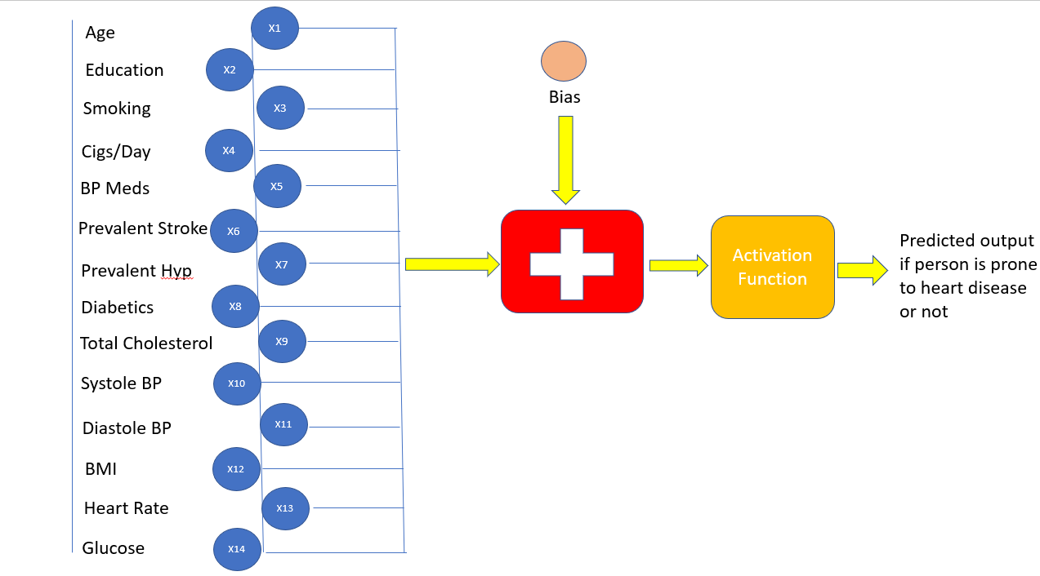

Fig. 1: Depiction of Logistic Regression for our model

Figure 1 illustrates the working of logistic regression algorithm. It shows how number of inputs is biased and then activated to finally give one input if the patient is prone to heart disease or not.

­­­­­­­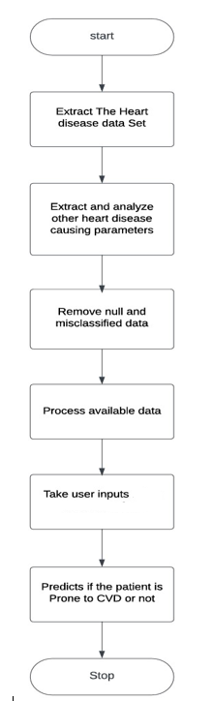

Fig. 2: Data Flow Diagram of the proposed system

figure 2 illustrates the data flow through the machine learning model, depicting input features and the subsequent prediction of output.

IMPLEMENTATION

Linked list has been used for Doctors due to their concept as dynamic data structures and resizablity at run time. Also insertion and deletion operations are easy to implement. A doubly linked list is acquainted because of their forward and backward traversals feature. Also, deletion of a node becomes easier because of the access to the previous node. For appointments we have made use of Queue. So, on a first come first serve basis patients would be waiting in queue for the respective doctors in their respective departments. For storing patient records like Patient ID, Patient name, age, address, phone number, gender etc used BST. They are stored according to Patient ID. For new patients taking these above details as well as old prescriptions and symptoms. For old patients we find their history according to their ID only. Patient details are stored in their respective departments. Here, we have used BST due to its ordered structure. BSTs are used for indexing and multi-level indexing. Also, they are helpful for sorting algorithms. It is helpful in making a sorted stream of data. Hashing has been implemented for storing medicine data. Hashing is preferred because we need to store data in key and value pairs i.e. Key for medicine name and their prices. Here in hashing we have performed insertion, deletion and updation of medicine. The Hash Table was implemented considering our requirements.

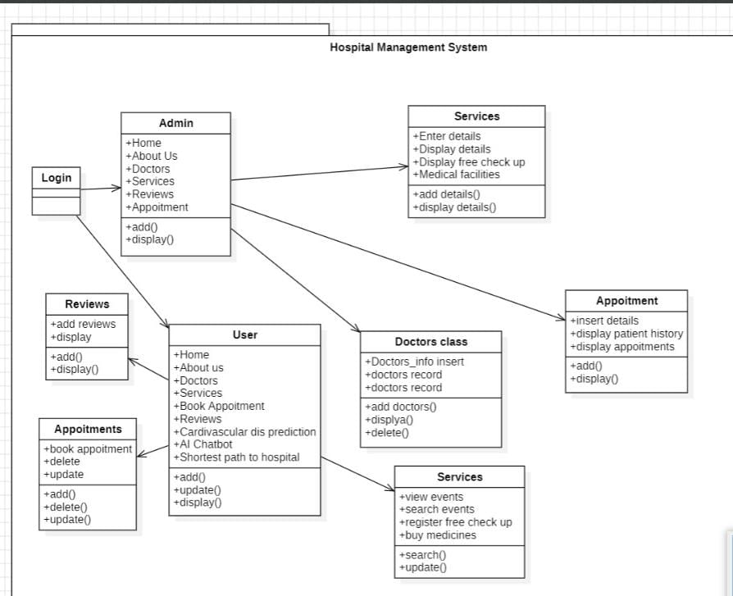Additionally, Hash tables were selected because of its speed and accuracy to perform insertion, deletion and search operations. - Here, collision has been handled using double hashing probing. We have implemented Array list to store Reviews. It provides constant time for search operation Searching is more frequent operation than add and remove operation. Logistic Regression Algorithm is used for predicting the chances of Cardiovascular diseases. Dijkstra Algorithmis used to find the shortest route between one location to destination. Bellman fordalgorithm is used to predict the cheapest cost to arrive at the hospital

Coming to the implemented machine learning model, it is essential to use proper and valid data for a machine-learning model. Machine learning means to train machines with raw data. These raw data have different parameters and a target parameter. Data has been obtained from Kaggle. We have tried implementing a machine-learning model for Heart prediction. We have used a machine learning algorithm known as Logistic Regression. Logistic Regression falls under binary classification. First we find Sigmoid function using that we train and predict the result according to data. It in this case uses its parameterized data to predict if the patient is prone to heart diseases or not. It is important to predict heart diseases well in advance to keep ourselves safe. Accurate data as well ensuring major discrepancies are key for better deployment of the model. Data has been obtained from multiple people who have checked for cardiovascular diseases in the last 10 years. CVD in the last 10 years is taken as the target parameter from the data. We have looked into other parameters i.e. age, education, and smoking status. Cigarettes per day, Prevalent Strokes, Diabetes, Sys BP, Diastolic BP, BMI, BP medicines, Total Cholesterol, Heart rate, and glucose. We have got it in the format of CSV file or the Excel format for easy use and accessibility. The dataset is split and trained and tested in 80:20 ratio

##### RESULT AND FUTURE SCOPE

We have tried using multiple DSA Algorithms to build the most efficient solution for data handling in Hospital Management System. To analyse the precision and performance of the model we have used ROC Curve and confusion matrix. Confusion Matrix tells us the performance of the Machine learning model. It has four instances, True Negative, False Positive and False Negative, True positive. Through confusion matrix we were able to identify that the accuracy of the model is around 88.2. 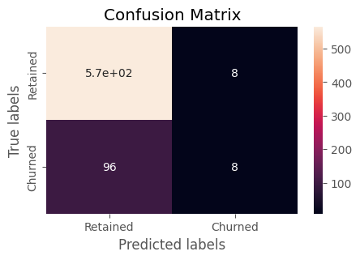

Fig. 3: Confusion Matrix of ML Model that predicts accuracy of the model

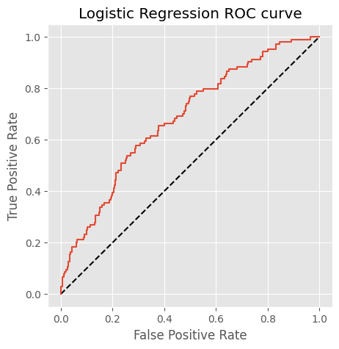

Fig. 4: ROC Curve showing the actual deviation of models prediction from apparent prediction

The receiving operator characteristic curve (ROC) shows the performance of a classification model at the classification threshold. We were also able to make from outputs that people who smoke less are less prone to Heart diseases. Apparently This model was expected to predict if the person is prone to heart diseases or not with cent percent accuracy but it is able to achieve an accuracy of 88.8 percent in actual scenario. 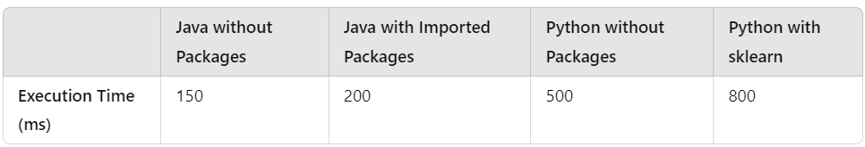

The model is built over java without using any inbuilt packages making it work fastest and more accuratly compared to other languages.

The hospital management system using DSA has immense potential for future advancements and developments. Some of the potential future scope of this system includes, the integration of artificial intelligence can help hospitals to automate several processes such as patient diagnosis, resource utilization, and billing management, thereby improving the quality of patient care and reducing operational costs. The integration of Internet of things can enable hospitals to monitor patient health in real-time, providing early detection of any health issues. The integration of block chain technology can enhance the security and privacy of patient data, making the system more secure and transparent. In conclusion, the advanced hospital management system project developed using DSA is capable to reform the healthcare industry, enabling hospitals to operate more efficiently and improving patient care. The future scope of this system is vast, and with the continuous advancements in technology, we can expect to see more innovative features and capabilities being added to the system

CONCLUSION

An Advanced Healthcare Management System is the most essential component for efficient and effective healthcare delivery. It is important to improve the quality of patient care, ease of use, reducing healthcare costs and optimizing vast data handled. The hospital management system using DSA (Data Structures and Algorithms) is an innovative solution that utilizes efficient algorithms and data structures to optimize the management of hospitals. The application provides a range of features such as staff management, inventory management, patient management and billing management which enable hospitals to improve their operational efficiency and provide better patient care. Healthcare Management systems has the potential to be the robust healthcare solution for all the data menaces. The system is designed to be efficient, fast and scalable enabling hospitals of all sizes to benefit from its features. The use of efficient algorithms and data structures ensures that the system can handle large amount of data while maintaining high performance.

Chances of heart attack, Cardiac arrest and many other heart diseases can be predicted using Logistic Regression model. This method is faster, more accurate and versatile. By developing this application, we have tried reducing the chances of heart diseases, especially among rural groups with aged population. We have also tried showcasing how Smoking and other parameters can impact heart diseases.

##### References

1. Y. Wang et al., "Parallel Hospital: ACP-Based Hospital Smart Operating System," 2021 IEEE 1st International Conference on Digital Twins and Parallel Intelligence (DTPI), Beijing, China, 2021, pp. keywords:Training;Hospitals;Operating systems;Digital twin;Conferences;Parallel hospital;Smart hospital;Digital hospital;Smart management;Smart training},
2. Nurhayati Fitriani,Reza Fuad Rachmadi, Prasetiyono Hari Mukti ; Knowledge Management Integration in Hospital Management Information System (SIMRS) Implementation in XYZ Hospital ;2023 IEEE 7th International Conference on Information Technology, Information Systems and Electrical Engineering (ICITISEE)
3. A. Fitriani, A. Y. Ridwan and L. Septiningrum, "Designing Green Hospital Non-Medical Waste Management System Based on ERP," 2022 International Conference on Data Science and Its Applications (ICoDSA), Bandung, Indonesia, 2022,;Pollution;Hospitals;Green products;Decision making;Manuals;Data science;ERP;green hospital;integration,Waste management
4. Thirupati Sai Eswar Reddy, Satwik Reddy Sripathi, Dhanush Akula, Suja Palaniswamy and Subramani R , “Cardiovascular Disease Prediction using Machine Learning and Deep Learning”, 6th International Conference on Computation System and Information Technology for Sustainable Solutions (CSITSS), 2022.
5. Kapil Joshi , G. Abhishek Reddy ,Sachin Kumar, Harishchander Anandaram, Ashuleka Gupta and Himanshu Gupta, “Analysis of Heart Disease Prediction using Various Machine Learning Techniques: A Review Study”, International Conference on Device Intelligence, Computing and

Communication Technologies, (DICCT), 2023.

1. Anusha M, Suresh K, and Chandana M, “ Earlier Prediction on the heart disease based on supervised machine learning techniques”, 5th International Conference on Intelligent Computing and Control Systems (ICICCS), 2021.
2. Narendra Mohan, Vinod Jain and Gauranshi Agarwal, “Heart Disease Prediction Using Supervised Machine-learning Algorithms”, 5th International Conference on Information Systems and Computer Networks (ISCON), 2021.
3. Seemadri Subhadharshini, Suraj K Nayak , Kishore K Tarafdar , Sirsendu S Ray , and Kunal Pal, “Understanding the Effect of Smoking on the Cardiac Activity of Young Female Smokers using EMD Analysis of ECG Signals”, 15th IEEE India Council International Conference (INDICON), 2018
4. A. Mandel, V. Maksakov, Y. Dorofeyuk and M. Shifrin, "Electronic Medical Records as a Tool of a Large Hospital Management," 2019 Twelfth International Conference "Management of large-scale system development" (MLSD), Moscow, Russia, 2019,.

keywords: Hospitals;Process control;Electronic medicalrecords;Controlsystems;Organizations;

large hospitals;management system;electronic medical records,

1. S. B, R. S, D. G and N. T, "Design and Development of Smart Hospital Management and Location Tracking System for People using Internet of Things," 2022 International Conference on Augmented Intelligence and Sustainable Systems (ICAISS), Trichy, India, 2022,. keywords: Cloud computing;Hospitals;Biometrics (access control);Urban areas;User interfaces;Developing countries;Mobile applications;Internet of Things;GPS;Nearest;hospital;Android App;Cloud,,
2. Syed Saad Azhar Ali4 and Manzoor Ahmed Hashmani5;Liver Patient Classifi cation using Logistic Regression ;2018 4th International conference on computer and information science(ICCOINS)